Name __________________________________________________

What can local buildings tell us about the past?

An oast house A pickers hut
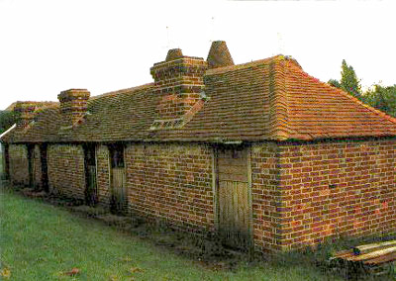
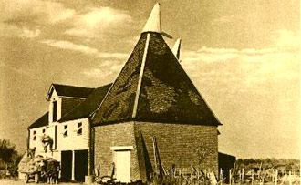

Use these pictures to help you complete this table:

Building | What does it look like? | How big is it? | What is it used for? | What are the surroundings like? | Why do you think it was built? | Who might have lived/worked/visited here?
The oast house
The pickers hut

Swap sheets with a friend. Use the website to check each other answers.

How accurate do you think your friend was?
______________________________________________________________________________________________________________

