Name __________________________________________________

What can photographs tell us about the past?

Look at these three pictures and complete the table below:
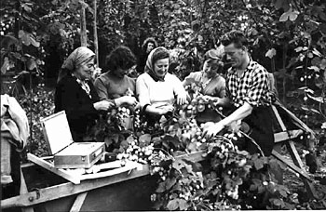
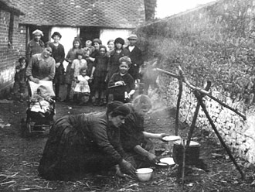
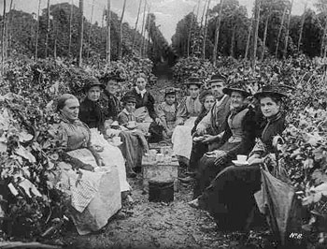

Picture 3
Picture 2
Picture 1

Picture | What does this tell us about the area and people in the past? | What has changed and what has stayed the same? | Why and how do you think this picture was made? | Who might it have been made for? | Do you think it is posed or natural?
Picture 1
Picture 2
Picture 3
In groups chose one of the pictures to recreate. Carry on the scene after the photograph has been taken. What are you doing? What are you talking about?

