Name __________________________________________________

What can written sources tell us about the past?

Look at the list of addresses (below) from a farmers address book. These are the contact details of hop-pickers who have worked for him before.

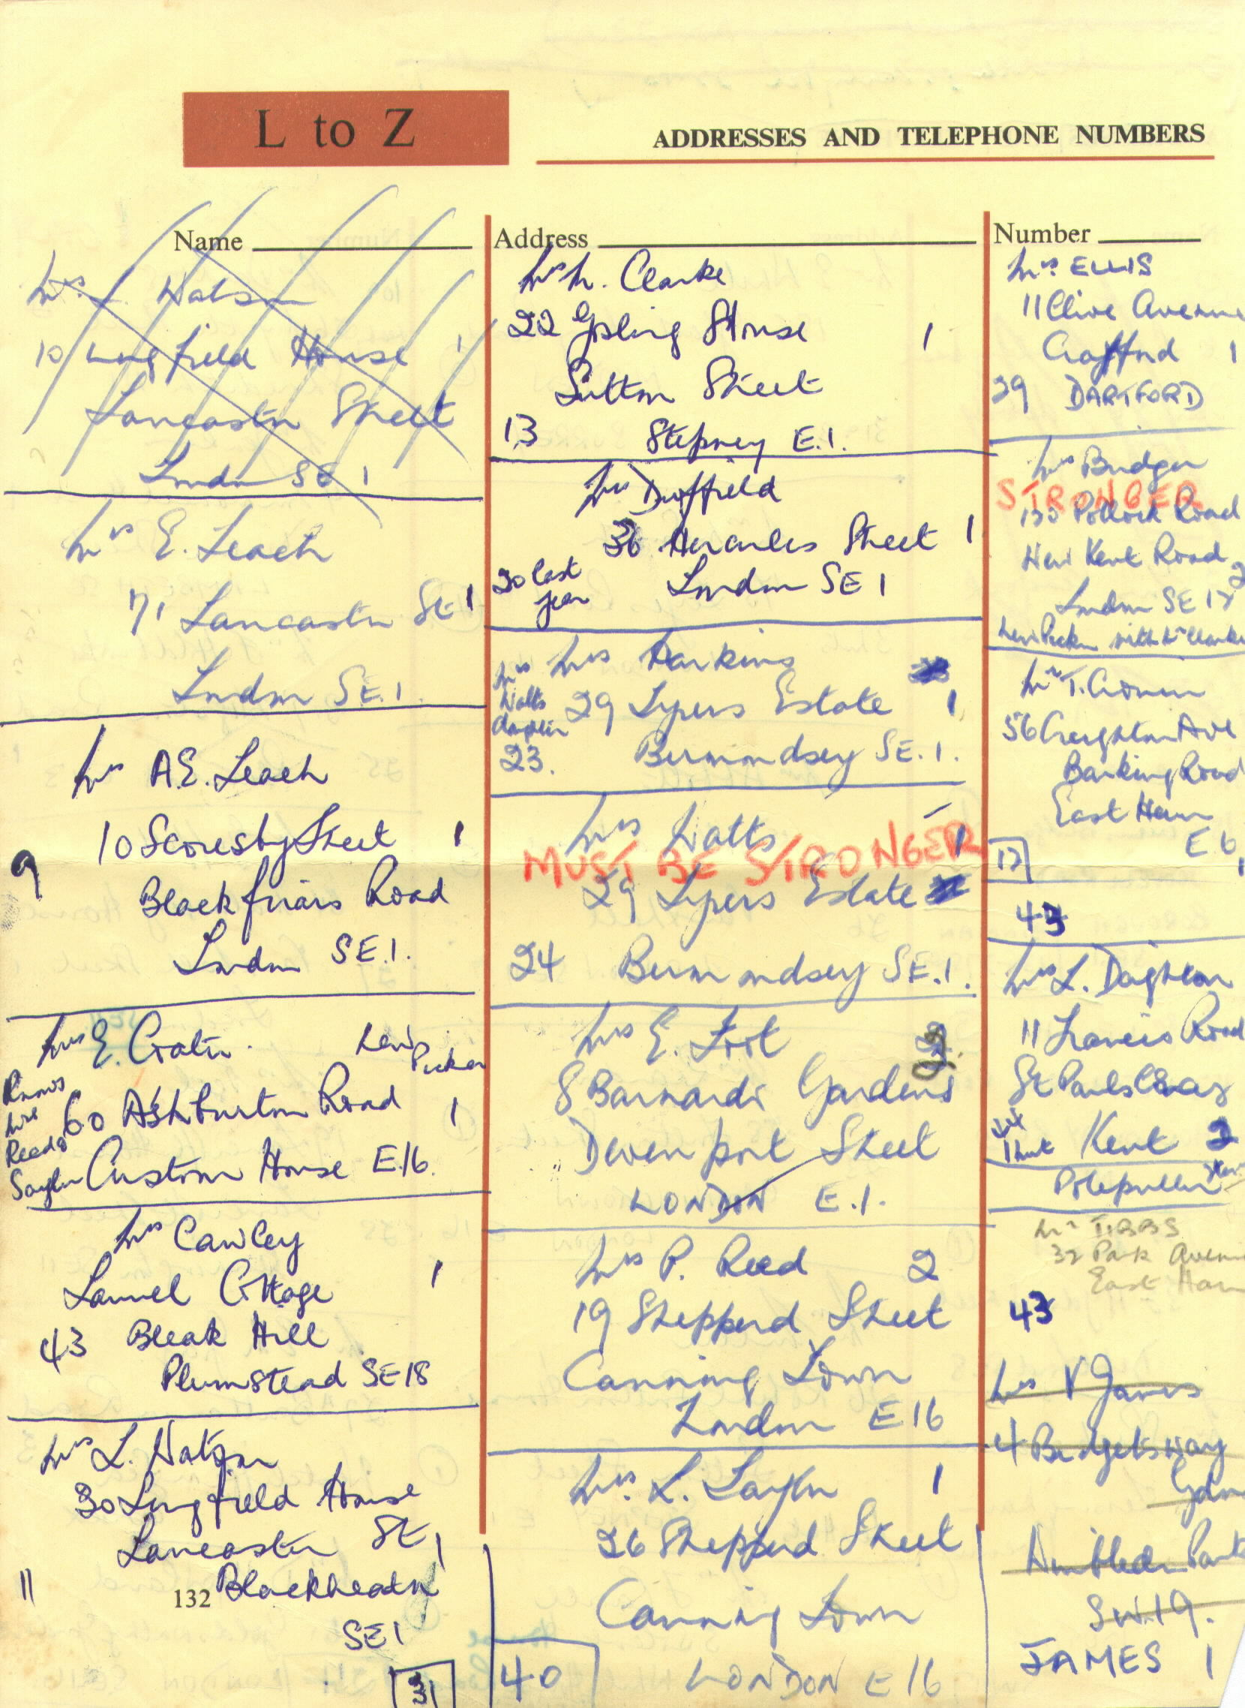

Postcodes starting with S.E., E. or N. before a number are from London.

Try to read the farmers handwriting and make tallies on this chart to record numbers:
London address
Address outside London
Addressed to a woman (Mrs)
Addressed to a man (Mr)

Were more of the pickers in the address book from London or from outside London?

Were most of the pickers in the address book men or women?

Can you see any other notes the farmer has made? What do you think they mean?

